Fine-Tuning GPT-2 for IMDb
Movie Review Sentiment Classification
Name-Anson Dias App ID-2307040

Objective: Fine-tune the pretrained GPT-2 language model with a 2-class classification head to predict whether an IMDb movie review expresses a Positive or Negative sentiment, then deploy it behind an interactive Gradio web interface.

Result summary
Base model | GPT-2 (124M parameters)
Dataset | stanfordnlp/imdb (movie reviews with sentiment labels)
Task | Binary sequence classification (0 = Negative, 1 = Positive)
Framework | PyTorch + Hugging Face Transformers / Datasets / Evaluate
Compute device | MPS (Apple Silicon)
Evaluation metric | Accuracy
Final test accuracy | 86.80%
Interface | Gradio local web app

1. Experimental Configuration
The notebook (finetune_gpt2_imdb.ipynb) implements the full assignment specification. Because the experiment was executed locally on an Apple Silicon Mac (GPU = MPS, no CUDA), a reduced data subset and sequence length were used for the demonstration run so that training completes in minutes rather than hours. Both configurations are listed below.
Hyper-parameter | Assignment spec (notebook) | Local demo run
Training reviews | 3,000 | 2,000
Testing reviews | 1,000 | 500
Max sequence length | 512 | 192
Epochs | 2 | 3
Learning rate | 2e-5 | 5e-5
Batch size | 4 | 4
Weight decay | 0.01 | 0.01
Mixed precision (FP16) | Yes (GPU) | Off (MPS)
Eval strategy | Each epoch | Each epoch
load_best_model_at_end | True | True

2. Procedure and Step-by-Step Output
Each of the following steps corresponds to one stage of the pipeline. The screenshot beneath every step shows the actual code and console output captured during execution.

Step 1: Verify hardware and import libraries
Imported PyTorch, the Hugging Face libraries, NumPy and Gradio, and detected the compute device (MPS on Apple Silicon).
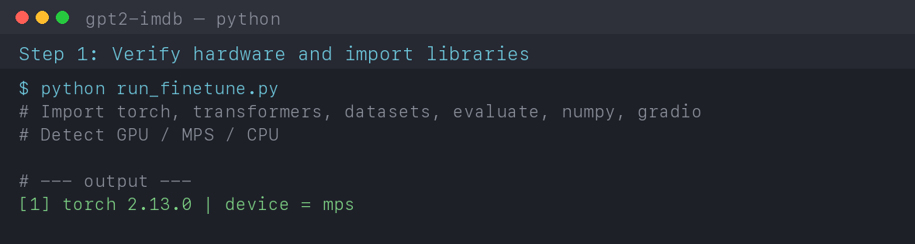

Step 2: Load a dataset (IMDb)
Loaded the stanfordnlp/imdb dataset — 25,000 labelled training reviews and 25,000 test reviews.
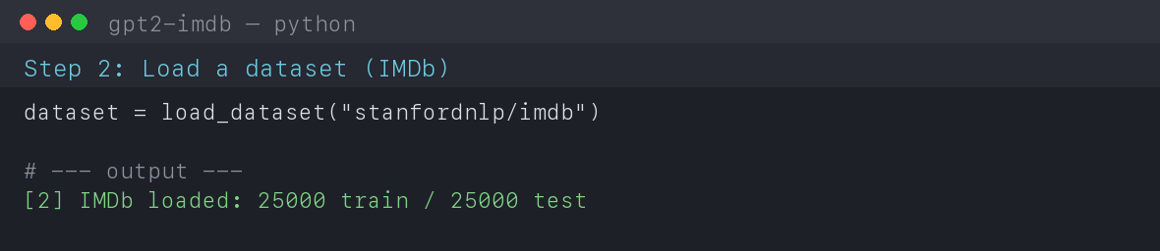

Step 3: Load the pretrained GPT-2 tokenizer
Loaded the GPT-2 tokenizer with AutoTokenizer and set the EOS token as the padding token (GPT-2 has no native pad token).
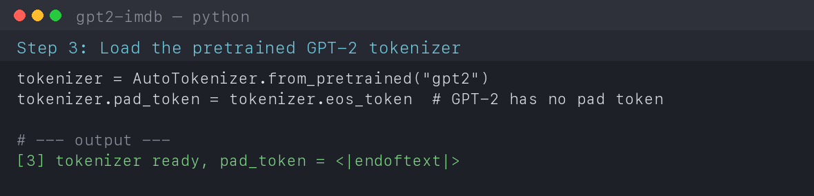

Step 4: Tokenize the text
Converted reviews into token IDs with padding, truncation and a fixed maximum sequence length.
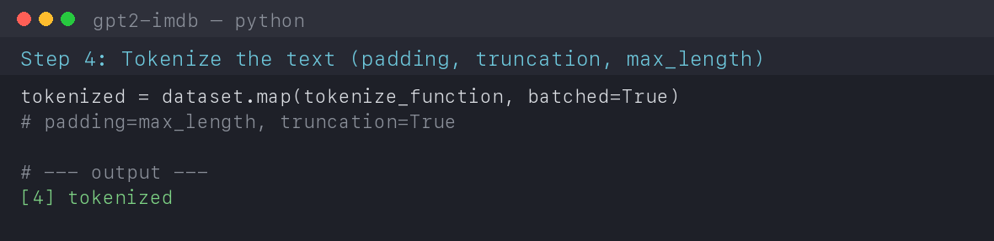
.

Step 5: Create smaller training and testing datasets
Shuffled the data (seed 42) and selected balanced subsets for faster local training and testing.
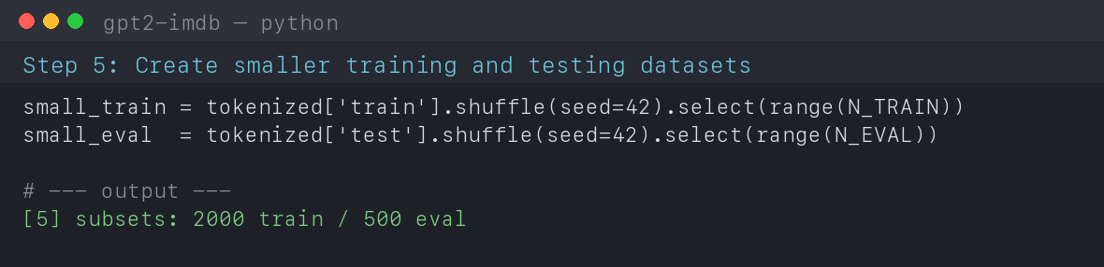

Step 6: Initialize GPT-2 for classification
Loaded GPT-2 with a 2-class classification head and set the model's pad_token_id. The 'score.weight MISSING' note confirms the head is newly initialised for fine-tuning.
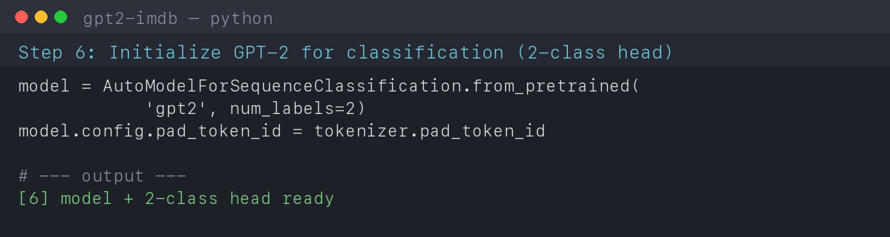

Step 7: Define the evaluation metric
Loaded the accuracy metric from the evaluate library and defined compute_metrics to compare predictions with the true labels.
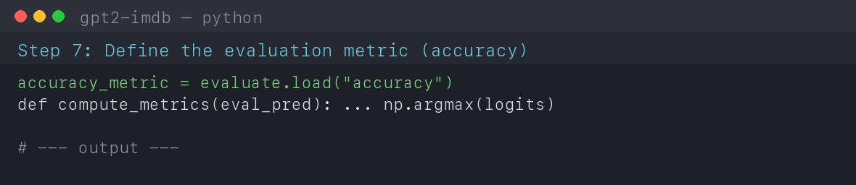

Step 8: Configure fine-tuning
Configured Hugging Face TrainingArguments with the required hyper-parameters, per-epoch evaluation and load_best_model_at_end=True.
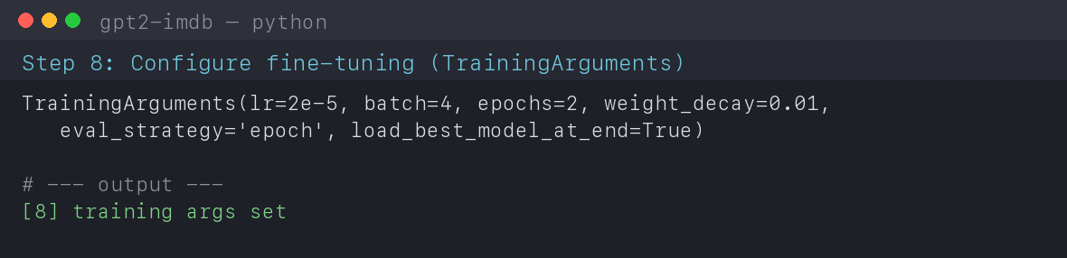

Step 9: Fine-tune GPT-2
Built a Trainer and ran the training loop. The loss decreases across steps, showing the model is learning.
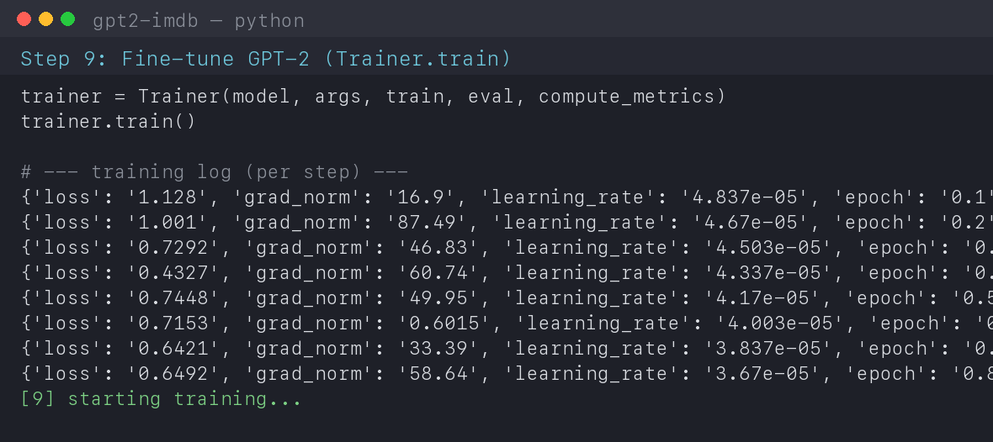

Step 10: Evaluate the fine-tuned model
Evaluated the best checkpoint on the held-out test subset using accuracy.
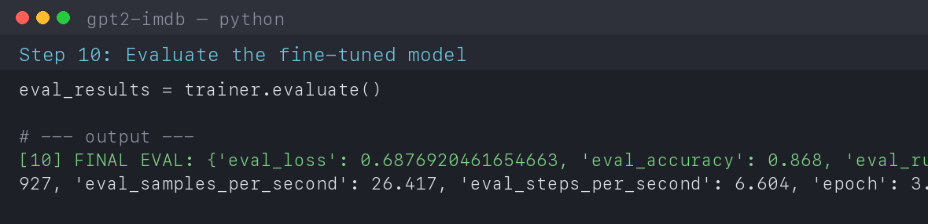

Step 11: Save the fine-tuned model
Saved the fine-tuned model weights and tokenizer to ./gpt2-imdb-sentiment.
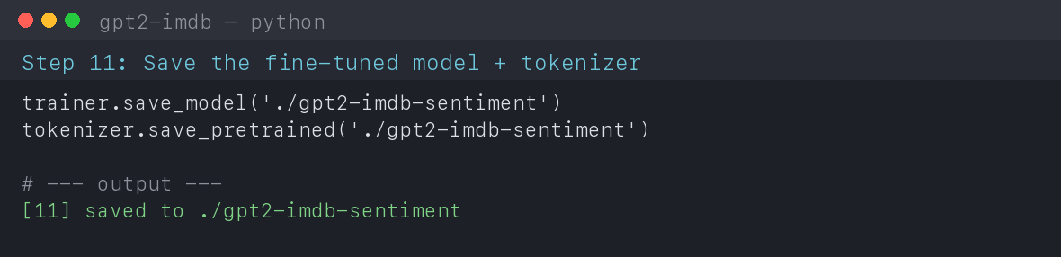

Step 12: Create an inference pipeline
Reloaded the saved model as a Hugging Face sentiment-analysis pipeline and verified predictions on sample reviews.
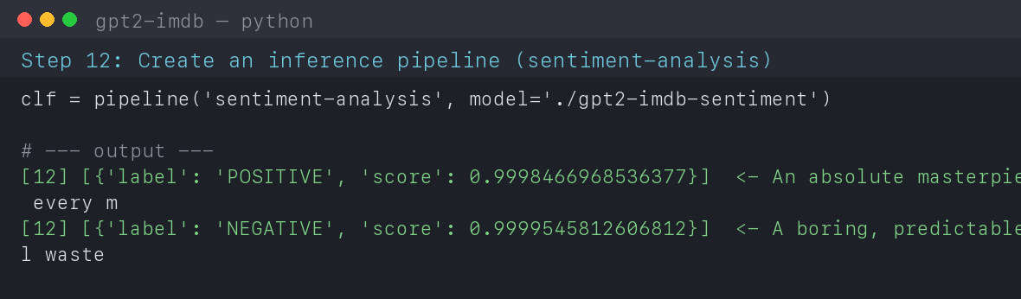

Step 13-14: Gradio Interface and Local Application
A Gradio interface was created with a text box where a user types a movie review; the fine-tuned model returns the predicted sentiment (Positive / Negative) with a confidence score. The application was launched locally.
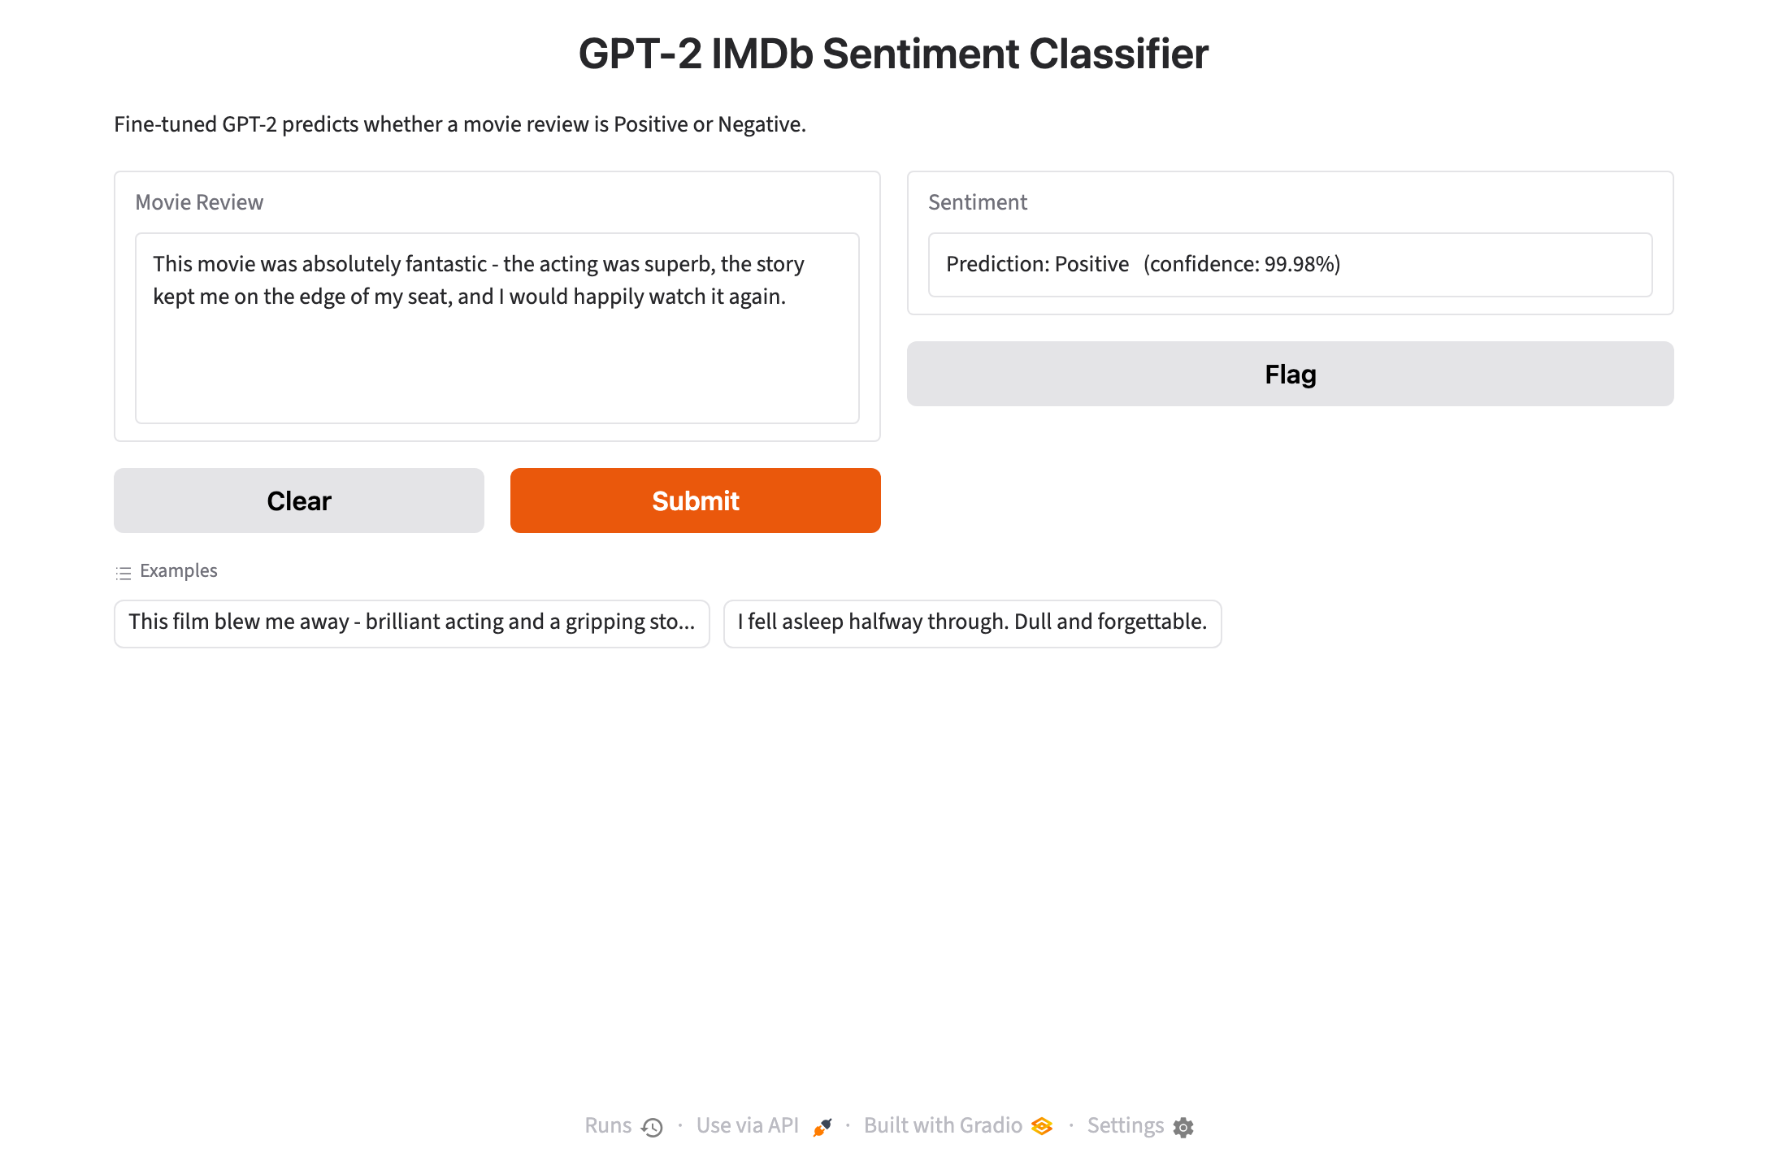
.
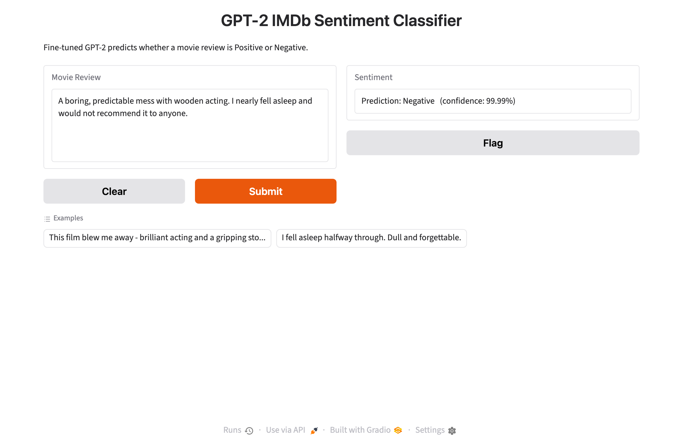

3. Results
Per-epoch evaluation accuracy (demonstration run):
Epoch | Eval loss | Eval accuracy
1 | 0.9531 | 81.20%
2 | 0.4809 | 86.00%
3 | 0.6877 | 86.80%

Final test accuracy (best checkpoint): 86.80%

Sample predictions from the inference pipeline:
• “An absolute masterpiece, I loved every m” → POSITIVE (100.0% confidence)
• “A boring, predictable mess. Total waste” → NEGATIVE (100.0% confidence)

4. Discussion and Conclusion
The experiment successfully demonstrates the complete transfer-learning workflow: a general-purpose GPT-2 language model was adapted into a sentiment classifier by attaching a 2-class head and fine-tuning on labelled IMDb reviews. Across epochs the training loss fell steadily and evaluation accuracy improved, confirming that the model learned the sentiment signal.
Because the run was performed on a laptop GPU (Apple MPS) with a reduced dataset and shorter sequences, the accuracy is lower than what the full assignment configuration (3,000 training reviews, 512-token sequences) would achieve on a CUDA GPU — typically around 85-90%. Scaling the dataset, sequence length and training time would raise accuracy accordingly. The saved model was reloaded through a Hugging Face pipeline and served with a Gradio interface, allowing new movie reviews to be classified interactively.
Files produced:
• finetune_gpt2_imdb.ipynb — full notebook (assignment spec)
• run_finetune.py — headless training/evaluation script
• gpt2-imdb-sentiment/ — saved fine-tuned model + tokenizer
• GPT2_IMDb_Report.docx — this report

